Create Employee collection to store (empno,ename,sal,comm,job,hiredate,manager:{mgrno,name},dept{dno,dname,loc})

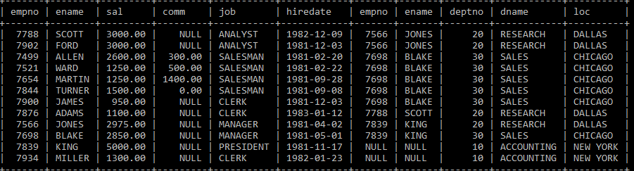

1. All Employee’s with the job as ‘CLERK’ are now called as (AO) Administrative Officers. Update the Employee table for this.(Hint Use multi:true)
2. Update salaries of all the SALESMAN , by increasing it by 100 $.
3. Increase the salary of KING by $ 300.
4. Delete the employees who get commission less than 100.
5. Find the SUM, AVERAGE, MINIMUM, MAXIMUM salary from the Employee table.
6. Count the number of employees in each department.
7. List highest sal of clerk.
8. List the sum of salary department wise.
9. Count the number of ‘CLERK’ in each department and their sum of salary.
10. List the department number who has more than 2 ANALYST.
11. Write query to display the employee number, name and salary of all ‘CLERK’ who work in Department 10.
12. Write a query to find employee number, name and job of all employees who are not managers or Analyst.
13. Write a query to find employee number, name and salary of all employees who get sal, less than 1000 or more than 3000, ordered by salary.
14. Write a query to find the name and employee number of all salesmen whose name begins with the letter S.
15. Use the IN operator to write a query to find the name and employee number of all employees who are analysts or managers, ordered alphabetically by name.
16. Write a query to find the employee number, name, salary and commission of all employees who have been paid commission and whose salary is greater than 1000.
17. Consider that the value in the Salary column is a monthly figure. Suppose that you are the owner of this company and you want to find out how much each employee would be paid per month if you increased his or her salary by 5%.
18. Again, consider that the value in the Salary column is a monthly figure. Suppose that you as the owner of this company want to compute how much each employee would be paid per month if you gave everyone a 3% pay cut. Write a query to get this information.
19. list the employee name and job of the employees whose commission is NULL.
20. List all the details from the department for which location is ‘Pune’.
21. List the employee name , department number of the employee whose salary is 3rd maximum.
22. List the names of the employees and their managers
23. list the employee name , job of the employees who do not belong to the department which in ‘CHICAGO’.
24. List the employee name and sal. In sal column display “greater” if sal >3000 else display ”equal” otherwise display “smaller”
25. List the name, department name, and employee number of all managers. Order the list in alphabetical order by department name.
26. List the employee name and department name of all employees Order the list in alphabetical order first by department name, then by employee name.
27. Write a query that will return all the unique department numbers that are represented in the EMPLOYEE table, ordered by department number.